射频电缆计算公式一览表
来源：互联网
Impedance (ohms)
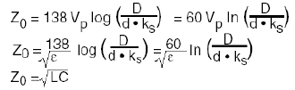
-----------------------------------------------------------------
Velocity of Propagation and Dielectric Constant
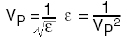
-----------------------------------------------------------------
Time Delay (nS/foot)
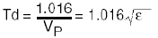
-----------------------------------------------------------------
Capacitance (pF/foot)
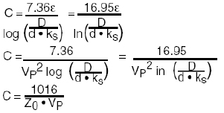
-----------------------------------------------------------------
Inductance (uH/foot)
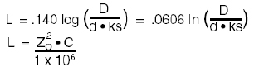
-----------------------------------------------------------------
Attenuation (dB/foot)
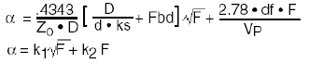
-----------------------------------------------------------------
Braid Factor
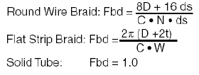
-----------------------------------------------------------------
Cutoff Frequency (GHz)
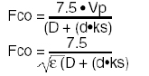
-----------------------------------------------------------------
Electrical Length (degrees)
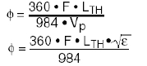
-----------------------------------------------------------------
Phase Temperature Coefficient (ppm/Co)
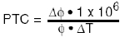
-----------------------------------------------------------------
Phase Stability (degrees)
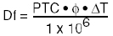
-----------------------------------------------------------------
Return Loss (dB)
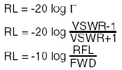
-----------------------------------------------------------------
VSWR
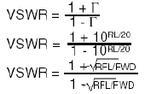
-----------------------------------------------------------------
Reflection Coefficient
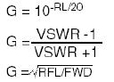
-----------------------------------------------------------------
Match Efficiency (%)
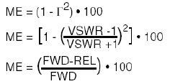
-----------------------------------------------------------------
Match Efficiency (%)
